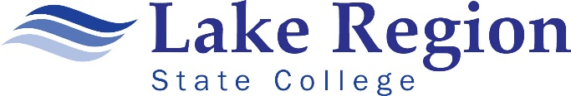**LAKE REGION STATE COLLEGE**

**Program Assessment Report**

**2022-2023**

Program assessment measures how students are learning as they progress through a specific program. The goals of program assessment are to ensure that the program’s mission, goals and student learning outcomes are being addressed across the curriculum, identify ways that the program can be improved, and inform faculty about relevant issues that can impact their program and student learning.

Every spring semester, the CTE faculty will complete the Program Assessment Report form and submit it to Cindy Brown, Assessment Committee Co-chair, at cindy.m.brown@lrsc.edu.

|  |
| --- |
| **Submitted By:** Click or tap here to enter text. |
| **Program:** Click or tap here to enter text. |

|  |
| --- |
| **Identify the program’s mission and goals:**  Click or tap here to enter text. |
| **Identify the program’s student learning outcomes:**  Click or tap here to enter text. |
| **Discuss the relationship between the program’s goals and LRSC’s mission:**  Click or tap here to enter text. |
| **Determine what assessment methods will be used to measure learning:**  Click or tap here to enter text. |
| **Describe the system used to compile and analyze the data:**  Click or tap here to enter text. |
| **Identify the changes that were or will be implemented in curriculum and /or teaching methods to improve learning:**  Click or tap here to enter text. |
| **Detail how the assessment data was used to improve student learning:**  Click or tap here to enter text. |